EXP-4
STRING HANDLING USING RAPTOR
Aim:
To design a flowchart using Raptor to display and return the total number of characters present in a given string.
Procedure:
1. Open Raptor and create a new flowchart.
2. Design flowchart steps:
• Input a string from the user
• Store the string in a variable
• Find the length of the string
• Display the total number of characters
3. Add flowchart logic:
• Use Input Symbol to accept the string
• Use Assignment Symbol to calculate character count
Example:
count ← Length(str)
• Use Output Symbol to display the count
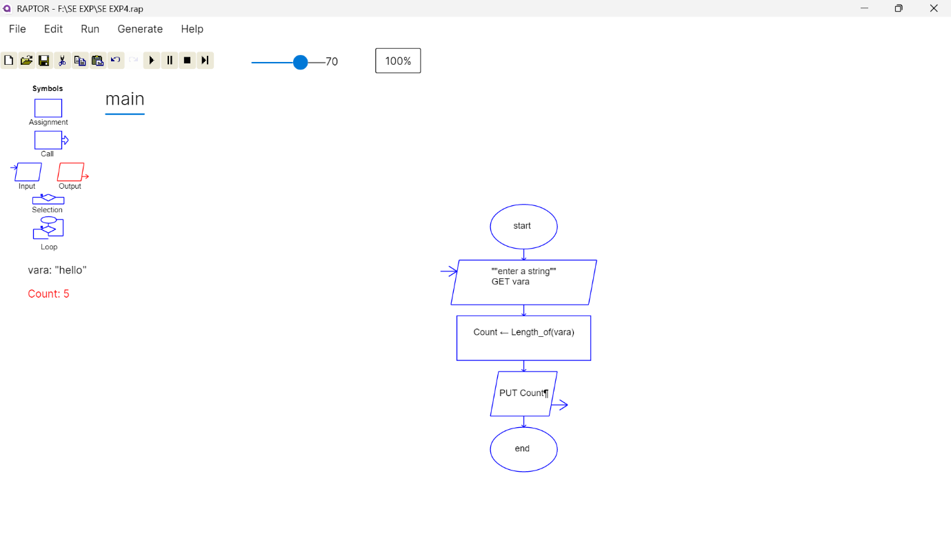
4. Execute and validate the flowchart using different string inputs.

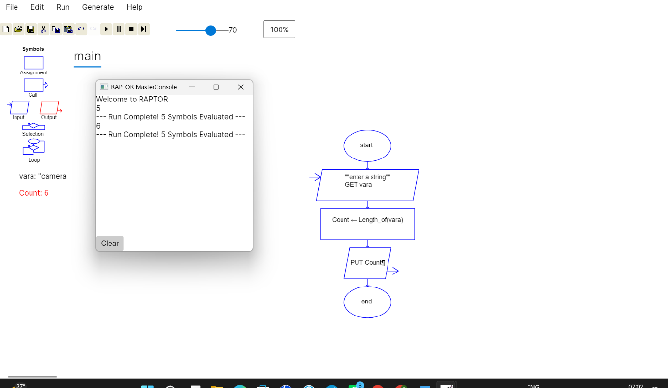
Result:
Thus, the flowchart for displaying and returning the total number of characters in a string was created and validated successfully using Raptor.

